Design and Implementation of a Secure Phone-as-Car-Key Platform for Car Rental Services

V-Model Design and Implementation Process - Android

Shane Power – 20102592

Introduction
This document records the step-by-step implementation of the Car Key App Android application, following the V-Model software development methodology. The V-Model was selected because it is the industry standard for safety-critical and automotive software - each development phase has a directly corresponding test phase, ensuring all requirements are verifiable and traceable throughout the project.
The Android application is one component of a larger system that includes a Python-based Vehicle Access Control Unit (VACU), Vector CANoe, and a cloud backend (Firebase). This document focuses specifically on the Android Car Key App.

V-Model overview
The V-Model structures development as a descending left arm (design/specification) and an ascending right arm (verification/testing), meeting at implementation at the bottom:
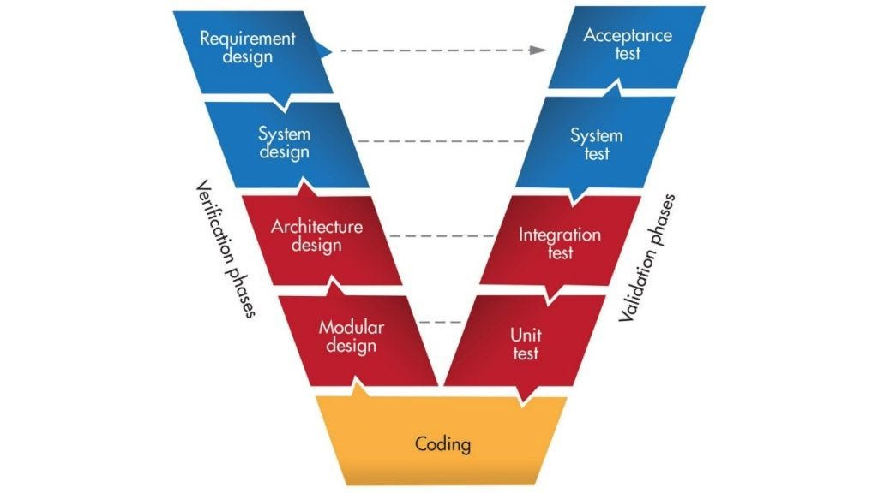
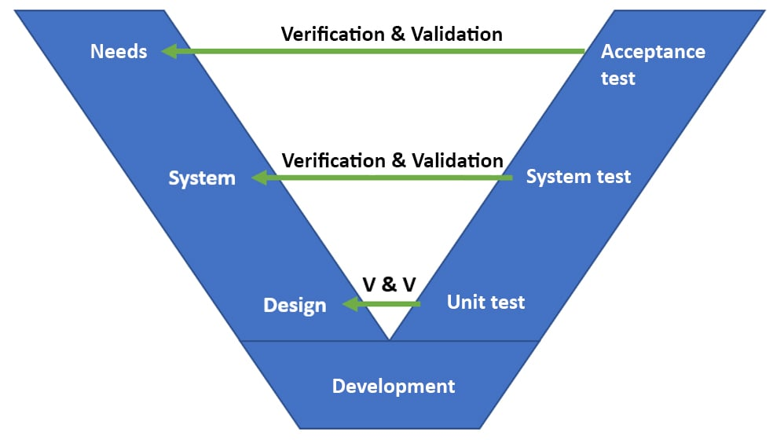
Requirements Analysis Validation Acceptance
System Design Verification Integration
Module Design Verification Unit Test
Development

Each section below corresponds to one phase of the V-Model, beginning at the top-left with Requirements Analysis.

Phase 1: Requirements Analysis
This phase directly corresponds with the Acceptance test phase. The goal of this phase is to define what the system must do, what data it must manage, and what the acceptance criteria are.

Functional Requirements
ID | Requirement
FR-01 | The app shall allow a registered user to log in using their email address and password via Firebase Authentication.
FR-02 | The app shall display the vehicle and digital key assigned to the logged-in user, retrieved from Cloud Firestore.
FR-03 | The app shall allow a user with an active digital key to send a lock command to the VACU over Bluetooth Low Energy.
FR-04 | The app shall allow a user with an active digital key to send an unlock command to the VACU over Bluetooth Low Energy.
FR-05 | The app shall prevent lock/unlock actions if the user's digital key has expired or been revoked.
FR-06 | The app shall include a nonce and timestamp in every BLE command to prevent replay attacks.
FR-07 | The app shall log every lock/unlock event (timestamp, userId, vehicleId, action, result, nonce) to Cloud Firestore.
FR-08 | The app shall allow the user to log out, clearing the active session.
FR-09 | The app shall display the current BLE connection status to the user.
FR-10 | The app shall support temporary guest keys with an expiry date.

Non-Functional Requirements
ID | Requirement
NFR-01 | The app shall allow a registered user to log in using their email address and password via Firebase Authentication.
NFR-02 | The app shall display the vehicle and digital key assigned to the logged-in user, retrieved from Cloud Firestore.
NFR-03 | The app shall allow a user with an active digital key to send a lock command to the VACU over Bluetooth Low Energy.
NFR-04 | The app shall allow a user with an active digital key to send an unlock command to the VACU over Bluetooth Low Energy.
NFR-05 | The app shall prevent lock/unlock actions if the user's digital key has expired or been revoked.
NFR-06 | The app shall include a nonce and timestamp in every BLE command to prevent replay attacks.
NFR-07 | The app shall log every lock/unlock event (timestamp, userId, vehicleId, action, result, nonce) to Cloud Firestore.
NFR-08 | The app shall allow the user to log out, clearing the active session.

Data Requirements and Data Models
The following data models were defined based on the functional requirements. These are implemented as Kotlin data classes and correspond directly to Firestore collections.

3.3.1 User
Represents a registered user of the system. Stored in the users Firestore collection.
data class User(
val userId: String = "",
val name: String = "",
val email: String = "",
val role: UserRole = UserRole.DRIVER
)
enum class UserRole {
DRIVER, // Can only lock/unlock their assigned vehicle
MANAGER // Can provision, assign and revoke keys
}

3.3.2 DigitalKey
Represents a provisioned digital key linking a user to a vehicle. Stored in the digitalKeys Firestore collection.
data class DigitalKey(
val keyId: String = "",
val vehicleId: String = "",
val userId: String = "",
val status: KeyStatus = KeyStatus.ACTIVE,
val expiryDate: com.google.firebase.Timestamp? = null,
val permissions: List<String> = emptyList()
)
enum class KeyStatus {
ACTIVE, // Key is valid and can be used
REVOKED, // Key was explicitly revoked by a manager
EXPIRED // Key passed its expiry date
}

3.3.3 Vehicle
Represents a vehicle in the fleet. Stored in the vehicles Firestore collection.
3.3.4 data class Vehicle(
val vehicleId: String = "",
val make: String = "",
val model: String = "",
val registrationPlate: String = "",
val currentKeyId: String? = null
)

VehicleEvent
Represents a logged lock or unlock event. Stored in the vehicleEvents Firestore collection. Every lock/unlock attempt is logged here for auditability.
data class VehicleEvent(
val logId: String = "",
val timestamp: com.google.firebase.Timestamp? = null,
val userId: String = "",
val vehicleId: String = "",
val action: VehicleAction = VehicleAction.UNLOCK,
val result: EventResult = EventResult.SUCCESS,
val nonce: String = ""
)
enum class VehicleAction { UNLOCK, LOCK }
enum class EventResult { SUCCESS, FAILURE }

